Faysal Khatri

CSC220 -- Activity 4

2017-06-14

# Part 1

#include <stdio.h>

int main() {

int myint = 5;

float myfloat = 8.9;

char mystring[] = "Hello";

struct mystruct {

int structInt;

int structArr[5];

};

struct mystruct a;

struct mystruct* aPtr;

aPtr = &a;

a.structInt = 7;

int* intPtr = &myint;

char* stringPtr = mystring;

printf("variable \t\t value \t\t address \t\t size\n");

printf("myint \t\t\t%d\t\t\t%p\t\t%d\n", myint, &myint, sizeof(myint));

printf("myfloat \t\t%f\t\t%p\t\t%d\n", myfloat, &myfloat, sizeof(myfloat));

printf("mystring \t\t%s\t\t\t%p\t\t%d\n", mystring, &mystring, sizeof(mystring));

printf("a (structure) \t\t%d\t\t%p\t\t\t%d\n", a, &a, sizeof(a));

printf("intPtr \t\t\t%p\t\t%p\t\t%d\n", intPtr, &intPtr, sizeof(intPtr));

printf("stringPtr \t\t%p\t\t%p\t\t%d\n", stringPtr, &stringPtr, sizeof(stringPtr));

printf("aPtr \t\t\t%p\t\t%p\t\t%d\n", aPtr, &aPtr, sizeof(aPtr));

printf("Value of myint: %d\n", *intPtr);

printf("Value of struct: %d\n", *aPtr);

return 0;

}

## Sample Output

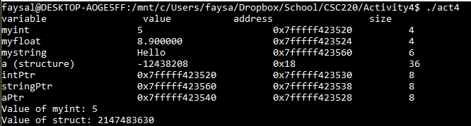

**NOTE**: I don’t know what is going on with the address of a, which is my instantiated structure. Even if I read aPtr there, I get 0x18.

# Part 2

#include<stdio.h>

#include<string.h>

int main () {

int n=0, len;

char str[ ] = "This is a string.";

len = strlen(str);

char* strPtr;

strPtr = &str;

for( n=0; n<len; n++)

putc( *(strPtr+n), stdout);

printf("\nn = %d\n", n);

}

## Sample Output

